Embodied Social Interaction Assistant

Sreekar Krishna, Troy McDaniel and Sethuraman Panchanathan
Center for Cognitive Ubiquitous Computing (CUbiC)
School of Computing and Informatics
Arizona State University, Tempe AZ 85281
Ph: 001 (480) 727 3612
Sreekar.Krishna@asu.edu

ABSTRACT
In this report we discuss the problem of building an assistive technology for people with sensory and/or cognitive impairment to aid in their everyday social interactions. Through an extensive background research, we identify some of the important design principles for developing an effective social interaction assistant. We demonstrate the use of these design principles through a novel computing platform that is capable of providing social assistance. Two experiments, based on the social needs of individuals with sensory or cognitive impairment, are discussed as examples of how the proposed embodied social interaction assistant can be used for enabling empathy and for offering social rehabilitation to those with needs. This article brings together various projects at CUbiC focused on the social interaction assistant, and provides insight into the plethora of problems that need the attention of researchers and scientists.
Keywords
Social Interactions, Social and Behavioral Modeling, Assistive Technology, Pattern Recognition, Computer Vision, Machine Learning.

INTRODUCTION

Social interaction in a nutshell
Social interaction refers to any form of mutual communication between two individuals or between an individual and a group [1]. Such communications involve any or all forms of sensory and motor activities as deemed necessary by the participants of the interaction. Researchers working in the area of social psychology, personality studies, developmental sociology and other related areas, strongly believe that the ability of individuals to effectively control expressive behavior is essential for the social and interpersonal functioning of our society. Such social interactions are the aggregate cause of social behaviors, social actions and social contact that helps not only in effective bilateral communication, but also in forming an efficient feedback driven behavioral learning loop. It is this feedback (termed as social feedback) that children use towards developing good social and communicative skills.
Recent studies in behavioral psychology are furthering our understanding of the importance of social behaviors and social actions in everyday context. Researchers have revealed an unconscious need in humans to mimic and imitate the mannerisms of their interaction partners. An increasing number of experiments have highlighted this need for imitation to be very primeval and that they offer an elegant channel for building trust and confidence between individuals (termed as empathy – a behavioral psychology term encompassing the ability of an individual to display vivid emotions, effective role taking, and the ability to understand others). Unfortunately, people with sensory disability (like visual and hearing impairment) and/or cognitive disability (like autism or developmental disorder) miss out on both social feedback and empathy due to the lack of appropriate sensory or cognitive processing.

Importance of social interaction
In popular literature, a person who interacts effectively and efficiently with others is said to possess Social Skills [2] or Communication Competence [3]. (In this reportwe will use these terms interchangeably.) Social skills are critical for successful everyday living. Acquisition of these skills normally begin at an early age. They play an important role in early social development and acceptance, and ultimately help people lead normal, healthy, successful lives. Good social skills allow a person to effectively integrate themselves socially into new situations, such as making new friends, or making a good first impression at a job interview. In contrast, studies by Segrin et al. [4] have shown that poor social skills are antecedents to psychosocial problems including depression, loneliness, and social anxiety. The authors conducted a battery of tests on college students to determine the effect of stress on the students when they live at least 200 miles away from home. There was a positive correlation between stress and an increased experience of psychosocial problems in all the students. However, the students who scored higher on social skills also showed a higher resistance to stress and, in turn, a higher resistance to mental breakdown. In contrast, students who scored low on social skills were highly vulnerable to social issues as the stress increased. People with higher communication competence are known [1] to display a greater ability to adapt their social behavior based on others in their environment (i.e. greater empathy). Such ability builds empathy in others, thus creating a reinforcement feedback loop that allows them to be successful in their social endeavors and, in turn, successful in their life.

Social Intelligence:
Researchers in the area of cognition and intelligence strongly believe that social interactions play a vital role in the overall development of primate brain. Interested readers are referred to [5] for a comprehensive discussion on social intelligence. Primate researcher, Humphrey, has argued strongly that social interaction is key to cultural transmission of knowledge and the development of intelligence. His studies with rhesus monkey [6] have emphasized the positive influence of social interactions on the development of general intelligence. For example, Helen (a rhesus monkey) had her visual cortex surgically removed and studies were conducted on her recovery of spatial vision. Over four years in the laboratory, Helen hardly recovered any of her spatial knowledge. However, when she was taken out of the laboratory into the real world and allowed to interact with objects and other monkeys, she regained three dimensional spatial vision within a few weeks.
Social intelligence has recently gained momentum from a neuro-physiological perspective. Advanced functional brain imaging is enabling researchers to study the workings of human brain under various functional conditions. Brothers [7] has worked extensively on the neuro-physiological patterns in primate brains that are associated with social behavior. Her work has established the presence of brain regions that are dedicated to social cognition (Social cognition is the processing of information that culminates in the accurate perception of dispositions and intentions of other people). She has proposed a network of neural regions that comprise the social brain: the orbito-frontal cortex (OFC), superior temporal gyrus (STG) and amygdala. Her work has been recently bolstered by studying autistics and controls under functional Magnetic Resonance Imaging (fMRI) [8]. The subjects watched another person’s eye expressions, and guessed what that person was thinking or feeling. The fMRI images confirmed Brothers observations of STG and amygdala activations during social cognition, and showed that people with autism display a cognitive disability in the amygdala which prevents them from making appropriate mental inferences of other people’s emotions or facial expressions. Authors conclude that a social brain does exist, and that teaching children and adults social skills could offer a means of increasing activations in the social brain. This conclusion is supported by behavioral research in autism that employs social interaction training and language skill training in children, to ameliorate the social deficits characteristic of autism spectrum disorders (ASD).

Disability – a hindrance to social interactions
Nearly 65% of all interpersonal communication is not explicitly expressed in words [9], but is communicated with non-verbal cues, such as prosody, facial mannerisms, and body behaviors. Generation of these cues is typically an unconscious act by the communicator, who must exercise vigilant self-monitoring to become aware of his/her own actions. It is the presence of these non-verbal cues in every social interaction that makes disability an enormous gap that needs bridging. For example, eye gaze plays a crucial role in social interaction as humans rely heavily on social gaze in virtually every form of communication, including infant/parent interactions, turn taking in group conversations, attention seeking and even effective learning. A person who is blind or visually impaired, and is unable to follow the eye gaze of their interaction partners, does not experience the benefits of eye gaze for either social feedback or for learning, and might fail to display empathy through imitation.
Recently, Jindal-Snape [10] carried out extensive research in understanding social skill development in the blind and visually impaired. She has studied individual children (who are blind) from India where the socio-economic conditions do not provide for trained professionals to work with children with disabilities. She observed that significant others in the environment often fail to give feedback, and even when they do, it is not meaningful or understandable to an individual who is visually impaired—for example, nodding one's head in reply to a question or gesturing. Lack of meaningful feedback could make it difficult for visually impaired individuals to comprehend a conversation and, at times, may stop them from conversing altogether. Similar studies carried out by Celeste [11] indicated that social intervention by parents and teachers are very important in the formative years of a child with visual impairment. Developing on the work by [12], which emphasizes that short-term solutions are never effective, Celeste insists that professionals must identify strategies related to social skills that work, provide consistent support and follow children longitudinally to ensure effective development of social skill set. We believe that an assistive technology solution that is designed with utmost care towards understanding and interpreting human-human interpersonal communications could go far and beyond in enabling and motivating individuals with disabilities to lead a healthier life.
When deprived of the benefits of social feedback, people with disabilities may develop (or fail to extinguish) face, body and vocal mannerisms that can be distracting or detrimental in social settings. Eichel [13] describes such mannerisms as “Any repetitive or stereotyped movement that is not directed toward the attainment of any observable (obvious) goal”. Non-disabled people receive social feedback by monitoring changes in non-verbal cues (such as facial expressions) as a conversation progresses, noting signs of positive or negative emotions. Such observations might not be accessible to people with a disability, due to a sensory disability or to an inability to process the affective content of an incoming sensory stream. As a result, people who are blind sometimes develop body rocking, head weaving, head drooping, and eye poking behaviors, while people who are deaf sometimes develop repetitive vocal behaviors. Cognitive disabilities, both acquired (such as brain injury) and congenital (such as autism or mental retardation) are sometimes associated with stereotypic behaviors such body rocking, hand flapping, jumping, and marching in place.
Though harmless by itself, Stereotypy can become a hindrance to both personal and professional lives of individuals. Reference [14] introduces a 21 year old congenitally blind student who has an extreme case of body rocking (both while sitting and standing) that has become an obstruction to his career and an independent vocational evaluation states that a reduction in the student's body rocking was absolutely necessary for any form of employment. Stereotypy is a concerning problem in children, for whom peer acceptance is very important for their healthy growth and development of good social skills. Children with stereotypic behaviors become victims of teasing thereby leading to social isolation, bullying and social segregation leading to negative self esteem. Aggravating these problems, social segregation and isolation have long term psychological effects on the individual rendering an overall poor social skill set.
We believe that a carefully designed assistive technology solution could provide the much needed assistance in empathy and social feedback that are vital for an individual’s overall development. The framework that we present in this reporttakes into account two most important aspects of social interactions namely, enabling empathy (providing opportunity for an individual at displaying vivid emotions, effective role taking, and understanding others) and social-rehabilitation (providing opportunity for social feedback) as the dimensions of design and suggests a novel computing platform that will allow seamless integration into the lives of individuals while also providing the much needed social intervention.

RELATED WORK
Affective Computing research has employed algorithmic framework to quantitatively study both verbal and non-verbal cues displayed by the humans during social communication. Signal streams from various sensors, including visual sensors (e.g. cameras), audio sensors (e.g. microphones) and various physiological sensors (such as EEG, EMG, and galvanic skin resistance sensors) have been used to evaluate human emotional states. A good review of research work in Affective Computing can be found in [15]. This research has enabled a better understanding of human physiological signals, with respect to emotional states, and the results have been used to facilitate human-computer interaction (HCI). In theory, a system that can detect non-verbal social cues could also be used as an assistive device to provide social feedback to people with disabilities. The emphasis here would not be so much on interpreting these cues as on presenting social cue information to the user, and allowing the user to interpret them. However, very little research has been done towards finding intuitive methods for presenting social cue information to humans. [16] developed a haptic chair for presenting facial expression information. It was equipped with vibrotactile actuators on the back of the chair that represented some specific facial feature. Experiments conducted by the researchers showed that people were able to distinguish between six basic emotions. However, this solution had the obvious limitation that the user needed to be sitting in the chair to use the system.
Observation 1: Assistive technology designed towards social assistance should be portable and wearable so that the users can use them at various social circumstances without any restriction to their everyday life.
People with disabilities are not always able to perceive or interpret implicit social feedback as a guide to improving their communication competence. However, they might be able to use explicit feedback provided by a technological device. Rana and Picard [17] developed a device called Self Cam, which provides explicit feedback to people with Autism Spectrum Disorder (ASD). The system employs a wearable, self-directed camera that is supported on the users own shoulder to capture the user’s facial expressions. The system attempts to categorize the facial expressions of the user during social interactions to evaluate the social interaction performance of the ASD user. Unfortunately, the technology does not take into account the social implication of assistive technologies. Since the technology is being developed to address social interactions, it is important to take into account the social artifacts of technology. A device that has unnatural extensions could become more of a social distraction for both the participants and users than as an aid.
Observation 2: Assistive technology designed towards social assistance should allow seamless and discrete embodiment of sensors or actuators making sure the device does not become a social distraction.
Vinciarelli et. al. [18] have described the use of discrete technologies for understanding social interactions within groups, specifically targeting professional environments where individuals take decisions as a group. They analyze the use of bodily mannerisms and prosody to extract nonverbal cues that allow group dynamics analysis. They rely on simple sensors in the form of wearable tags [19] which detect face to face interaction events along with prosody analysis to determine turn taking, emotion of the speaker, distance to an individual etc. Pentland describes these signals captured during group interactions as [20] honest signals. Some of his recent works [21] in the area of social monitoring hopes to capture these signals and provide feedback to individuals about their social presence within a group. The use of social feedback is illustrated elegantly in their work but their findings relied on sensors carried by all individuals involved in the study. Having everyone in a group wear sensors has proved to be a viable and productive approach for studying group dynamics. However, this approach is not viable as a strategy for developing an assistive technology, as it is not realistic to assume that everyone who interacts with a person with a disability will wear sensors.
Observation 3: Assistive technology designed towards social assistance should incorporate mechanisms embodied on the user to determine both self and other’s social mannerism.
In two independent experiments [22] and [14], researchers developed a social feedback device that provides intervention when a person with visual impairment starts to rock their body displaying a stereotypy. [22] designed a device that consisted of a metal box with a mercury level switch that detects any bending actions. The feedback was provided with a tone generator that was also located inside the metal box. The entire box was mounted on a strap that the user wears around his/her head. The authors tested it on a congenitally blind individual who had severe case of body rocking and they conclude that the use of any assistive technology is useful only temporarily while the device is in use. They state that the body rocking behavior returned to baseline levels as soon as the device was removed. Since the time of this experiment, behavioral psychology studies have explored short term feedback for rehabilitation [23], and these studies support the above observation that short term feedback is often detrimental to rehabilitation and subject's case invariably worsens. Unfortunately, due to the prohibitively large design of the device developed by these researchers, it was impossible to have the individual wear the device over long durations.
Observation 4: Assistive technology designed towards social assistance and behavioral rehabilitation should be used over long durations in such a way that the feedback is slowly tapered off over a significantly longer duration of time.
In [14] researchers used a 'Drive Alert' (driver alerting system that monitors head droop) to detect body rocking and provide feedback to a congenitally blind 21 year old student. The research concludes that they were able to control body rocking effectively, but the device could not differentiate between body rocks from any other functional body movements. This device, primarily built to sense drooping in drivers provides no opportunity to differentiate between a body rock and a functional droop. Use of such devices could only be negative on the user as a large number of false alarms would only discourage an individual from using any assistive technology.
Observation 5: Assistive technology designed towards social assistance and behavioral rehabilitation should be effective in discriminating social stereotypic mannerisms from other functional movements to keep the motivation of device use high.

Conceptual Framework

Design principles for social assistive and rehabilitative devices
A device that is developed to facilitate the social interactions of people with sensory, or cognitive disabilities might do so by (1) detecting social cues during social interactions and delivering that information to the user in real time to enable empathy, or (2) detecting the user’s stereotypic behaviors during social interactions and communicating that information to the user in real time to provide social feedback. The first device might be classified as an assistive technology, while the second might be classified as a rehabilitative technology. Ideally, such a device would be based on the following design principles:

Design principle 1: The device should be portable and wearable so that it can be used in any social situation, and without any restriction on the user’s everyday life.

Design principle 2: The device should employ sensors and personal signaling devices that are unobtrusive, and do not become a social distraction.

Design principle 3: The device should include sensors that can detect the social mannerisms of both the user and other people with whom the user might communicate.

Design principle 4: The device should be comfortable enough to be worn repeatedly for extended periods of time, to allow it to be used effectively for rehabilitation.

Design principle 5: The device should be able to reliably distinguish between the user’s problematic stereotypic mannerisms and normal functional movements, to ensure that it will be worn long enough to achieve rehabilitation.

Important factors in social interaction
To better understand the relative importance of various types of information during social interactions for people with visual disabilities, we conducted an online survey. The details of this online survey can be found in [24]. Table 1 summarizes those results, showing the relative importance of each type of information, where a higher score indicates more importance.
Along with the five design principles for social assistive technologies listed earlier, our development of an Embodied Social Interaction Assistant was guided by the rank ordering shown in Table 1. The rest of this reportdescribes our implementation of that device, and describes two experiments: one aimed at enabling empathy, and another aimed at providing social feedback.
Table 1: Social needs rank ordered based on online survey.
Need | Mean Score
Know my personal mannerisms | 4.5
Understand other’s facial expressions. | 4.4
Identify people around me. | 4.3
Understand other’s gestures. | 4.2
Know how many people there are, and where each person is. | 4.1
Know which way each person is facing or looking. | 4.0
Know the appearance of others. | 3.5
Know what others look like. | 3.4

EMBODIED SOCIAL INTERACTION ASSISTANT

System Architecture
The system level architecture of the proposed social interaction assistant is shown in the Figure 1. The sensor suite consists of: (1) a visual sensor (1.4 Megapixel camera), (2) a motion sensor (± 12g accelerometer), and (3) a 5-button clicker, which serves as a user interface. The social interaction assistant software (implemented on a Windows Operating System PDA) uses these sensors to collect information about the various social and behavioral mannerisms of the user and participants in the vicinity of the user. Interpretations of the social interactions generated by custom algorithms are communicated to the user through an actuator suite, consisting of: (1) a haptic belt and (2) a set of ear phones. The haptic belt encodes information in the form of vibrotactile cues, while the ear phones provide short audio cues.
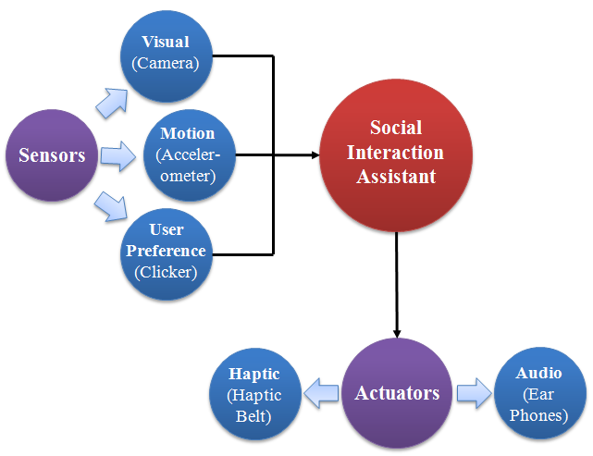
Figure 1: The System architecture of the embodied Social Interaction Assistant
Figure 2 shows the implementation of the proposed Social Interaction Assistant. A tiny video camera is placed unobtrusively on a pair of glasses, and a tiny state-of-the-art accelerometer is placed unobtrusively in a hat, and is used to monitor the user’s body mannerisms – particularly those related to head movement. (Most communicative gestures are encoded in movements of head [13] and the most widely occurring and problematic stereotypic body mannerisms are done with the head.) The accelerometer operates on a coin battery that allows for uninterrupted operation for over 4 hours.The user uses the 5-button clicker to control what types of information are delivered by the system. The haptic belt can be worn under the clothing, and the earphones are worn discretely under their hat. Thus, the proposed design of the assistive technology is (1) wearable, (2) portable, (3) unobtrusive, (4) self and other sensing, and (5) can be worn by the user for extended periods of time.

Enabling Empathy
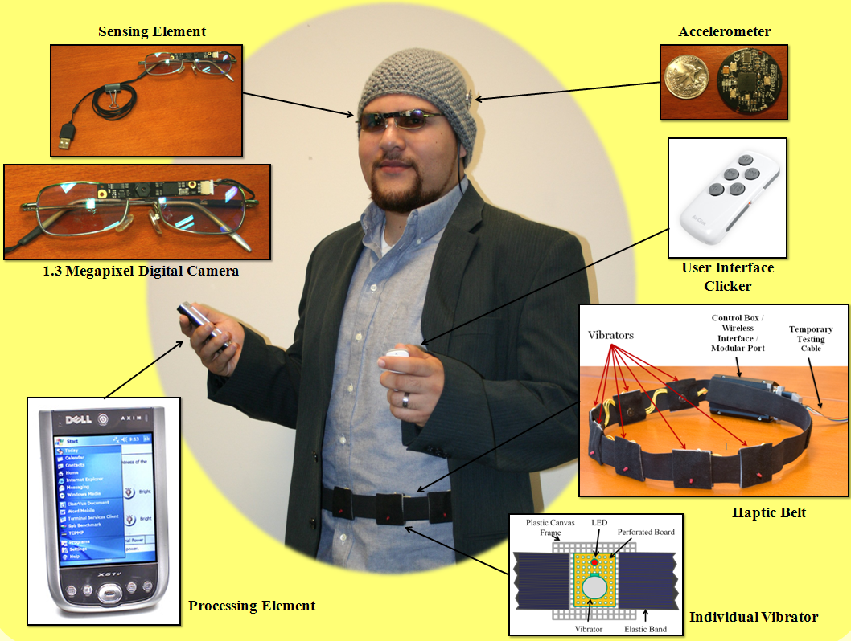
An important aspect of social interaction is social touch. A simple action such as a hug (in a personal setting) or a firm handshake (in a professional setting) helps establish a sense of trust and confidence. People who are considered to be socially competent use such non-verbal cues to be successful in their personal and professional life. Individuals who have sensory Sensing direction and distance and/or cognitive impairment sometimes find it awkward to engage in such social interactions because they are not able to perceive or comprehend the social situation in front of them. For example, people who are visually impaired might not be able to perceive where someone is standing relative to them, or at what distance that person is standing – information that is very important for initiating a social gesture. If a person wants to shake someone’s hand (or give them a hug) he/she might do so by walking towards the other person. This requires knowledge of where and how far someone is standing in front of the person. A person who is blind might not be able to determine this information, if the other person has not yet spoken. Toward this end, we propose to use the social interaction assistant to communicate the distance and direction to a nearby person.
Figure 2: the implementation of the Social Interaction Assistant

The video camera captures the scene in front of a user who is using the Social Interaction Assistant. We use the Viola et. al. [25] robust face detection algorithm for determining if a person is in front of the user. The central image in Figure 3 shows how the video frames are analyzed to determine the presence and location of a face, with respect to the user. (The details of the device functionality are given in [26].) Along with the left-to-right location of the face, the device uses the size of the detected face to estimate the distance between the user and the other person.
Thus, the detected face is used to determine: (1) the direction to the other person, and (2) the distance to the other person. As suggested by the study of Proxemics [27] we divided the interaction distance between the user and the participant into four distinct zones: (1) Intimate, (2) Personal Close, (3) Personal Far, and (4) Social Close.

Communicating direction and distance
The direction and distance to the other person are encoded in the form of vibrotactile signals that can be felt by the user who wears the haptic belt around his/her waist. The direction (encoded in terms of the seven numbered regions shown in Figure 3) is mapped to the seven vibrators on the haptic belt (see also Figure 3). The distance information is encoded in terms of the temporal sequences of on and off durations for those same seven vibrators. The temporal patterns used for the four interpersonal distance zones are shown in the Figure 4. The process by which these particular four temporal patterns were chosen is detailed in [28].
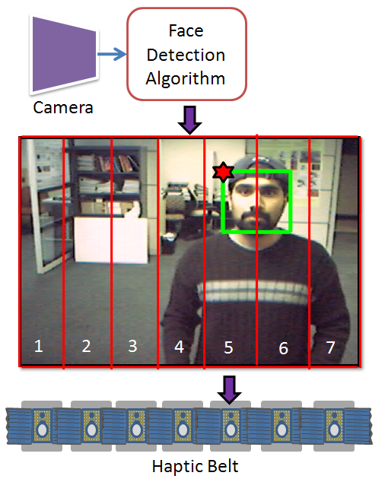
Figure 3: The Social Interaction Assistant detecting a person
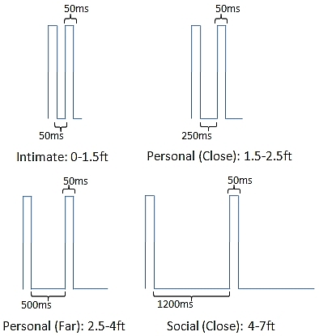
Figure 4: Encoding of distance information

Social-Rehabilitation
Body rocking has been identified as a very common stereotypic behavior in people with sensory and cognitive disabilities. Research has shown that sustained feedback (provided as a form of rehabilitative intervention) can help a user learn to control body rocking. We use the accelerometer in the Social Interaction Assistant to detect stereotypic body mannerisms. Figure 5 shows a typical output of the three axis accelerometer incorporated into the Social Interaction Assistant.
There is an obvious distinction between the periodic region of body rocking and those regions of non-rocking. The wireless accelerometer in the Social Interaction Assistant transmits the data at a rate of 100Hz to the PDA, where temporal analysis of the data stream is used to determine whether body rocking is present or not. To this end we use a Modest AdaBoost learning framework that is trained with rocking and non-rocking samples. The details of the features extracted from the accelerometer data and the parameters of the training can be found in [29].

EXPERIMENTS

Direction and distance of other person
The goal of this experiment was to test the ability of participants to identify specific interpersonal distance classes using the tactile temporal patterns shown in Figure 4, while also determining the directional vibrator where the temporal pattern was felt. Fifteen participants were tested on their ability to distinguish distance and direction encodings, and their recognition accuracies were averaged over 84 trials. The participants were first given examples of each of the direction and distance encodings. Then they were given direction/distance encodings at random, and asked to label each. After the experiment, the participants were asked to fill in a self report on how well they could distinguish distance and direction based on Likert scales—1 (lowest) to 10 (highest). We compared the self report of the participants with their actual performance.
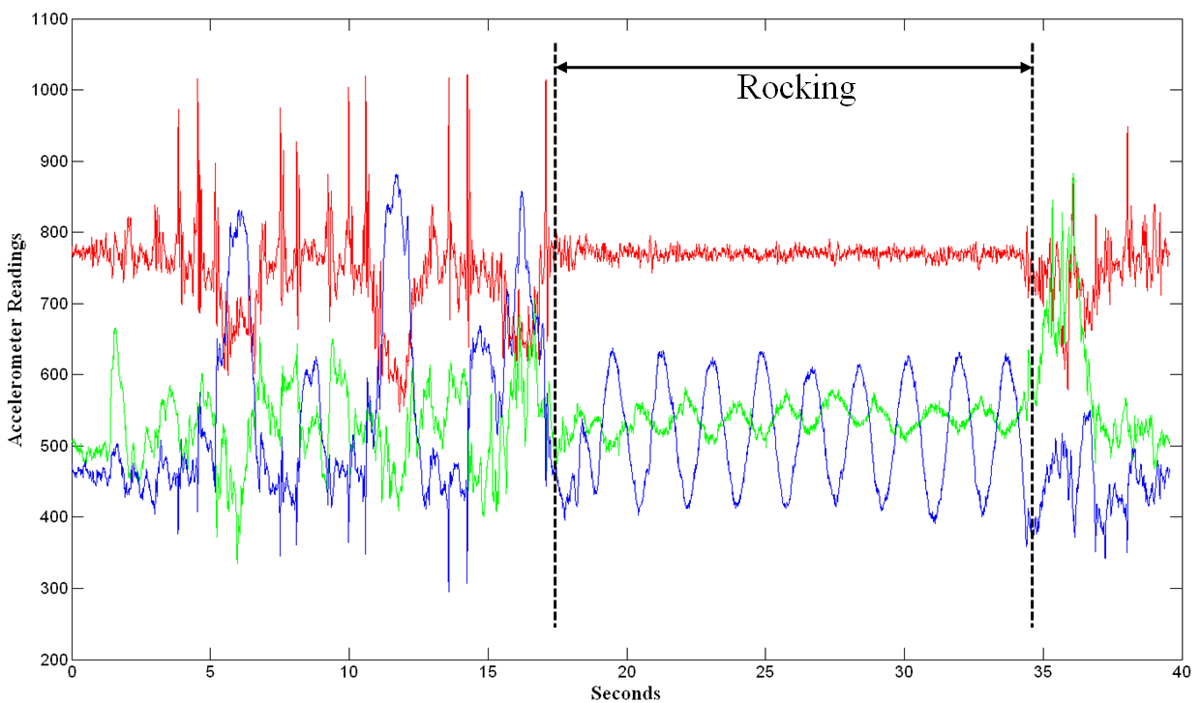
Figure 5: A typical output of the three axis accelerometer

Body Rock Detection
The goal of this experiment was to determine the ability of the Social Interaction Assistant to detect body rocking, and to distinguish it from other forms of functional movements that involved head drooping and bending. Ten people participated in the experiments, and from each participant three different sets of temporal data were collected. Sets one and two were collected for training the system, and consisted of examples of rocking and non-rocking, respectively. The third set of temporal data was a test set, with non-rocking data randomly interspersed with rocking data. For the test set, ground truth was created manually by marking the rocking and non-rocking events.

RESULTS

Direction and distance of other person
Figure 6 shows the overall direction detecting accuracy of the 15 participants. The seven bars correspond to the seven vibrators around the waist of the participant, with vibrator 4 being on the navel, and vibrators 1 and 7 on opposite sides of the waist. The y-axis shows the average detection accuracy, where 1 indicates perfect accuracy.
Figure 7 shows the overall distance detecting accuracy of the 15 participants. The four bars correspond to the four vibrotactile temporal patterns that represent the four interpersonal distances, as shown in Figure 4. The y-axis corresponds to the averaged detection accuracy, where 1 indicates perfect accuracy.

Body Rock Detection
The Social Interaction Assistant’s body rocking detector algorithm can use different window sizes to extract short sample streams from the data sequence produced by the accelerometer. Figure 8 shows a box plot of the performance of that detector, with respect to different window sizes (i.e. packet lengths). The abscissa represents both the packet length (in seconds) and the latency of detection. The ordinate represents the percentage accuracy of the body rock detection, which can also be interpreted as the percent number of times a body rock activity will be detected by the system while also not confusing functional activities with rocking.

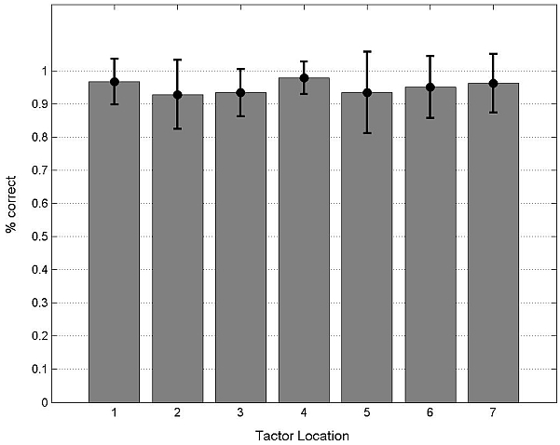
Figure 6: Overall direction recognition accuracy for each vibrator with standard deviations.
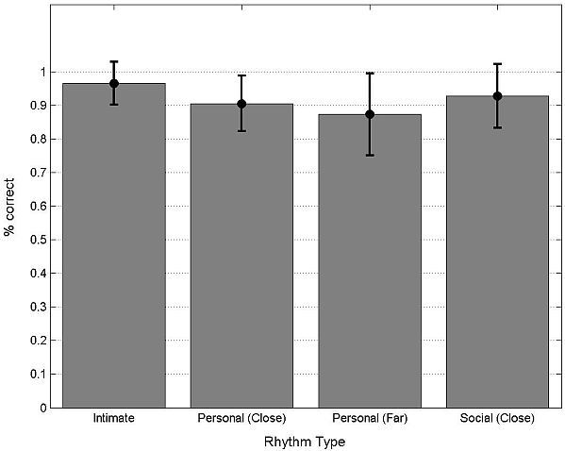
Figure 7: Overall distance recognition accuracy of each temporal pattern with standard deviations.

DISCUSSION OF RESULTS

Enabling Empathy
The overall recognition accuracy for each of the seven vibrators is shown in Figure 6. Subjects felt that vibrator #1 (left side), #4 (navel) and #7 (right side) were easier to localize than vibrators #2, #3, #5, and #6. This is matched by the slightly higher (but not significantly different) accuracies for the recognition these three vibrators (as seen in Figure 6), and is perhaps explained by the finding that spatial acuity is better at anatomical reference points [30]. The overall recognition accuracies for the four temporal patterns are shown in Figure 7. Subjects felt that rhythm #2 (personal-close) and #3 (personal-far) were more difficult to identify than rhythm #1 (intimate) or #4 (social-close). No interaction was found between vibrator and temporal pattern recognition accuracy. In the self-report, subjects estimated their ability to: localize vibrations (mean: 8.4), identify rhythms (mean: 7.4), intuitiveness of location to convey direction (mean: 9.7) and intuitiveness of rhythm to convey distance (mean: 8.9). Overall, the subjects felt that: (1) they could accurately identify the temporal patterns, (2) they could distinguish vibrators more easily than temporal patterns, and (3) the two types of vibrotactile encodings were intuitive representations of direction and distance, respectively.
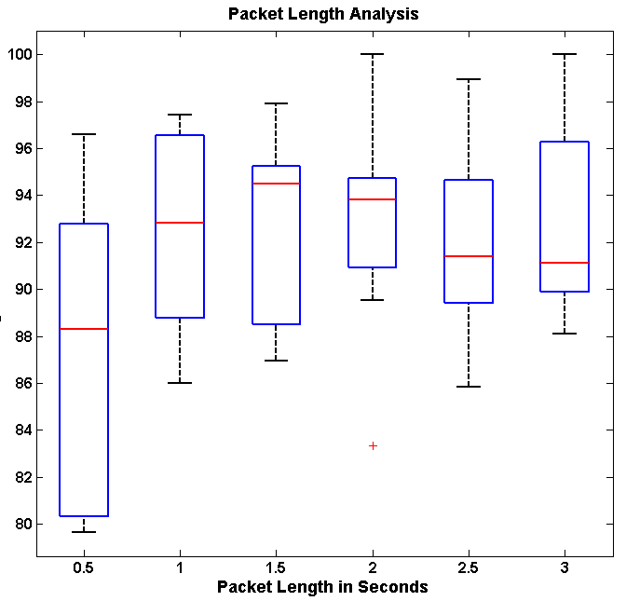
Figure 8: Packet length to body rock recognition rate comparison

Social-Rehabilitation
From Figure 8 we can see that the Social Interaction Assistant was able to detect body rocking with an accuracy somewhere between 89% and 95%, with the best performance occurring when the packet length for analysis is 1.5 seconds long, closely followed by 2-second packet length. The variance in the recognition rates (across the ten participants) is shown by the blue rectangular boxes. The variance for the 1.5-second packet length is considerable larger than for the 2-second packet length. The average natural rocking motion of the 10 subjects was around 27 rocks a minute (i.e. 2.22 seconds per rock). This is consistent with results from [31]) as well as with the optimal packet size in our experiments.

CONCLUSION AND FUTURE WORK
In this reportwe have highlighted the importance of social interactions, and have suggested that technology solutions might help people with sensory and/or cognitive disabilities engage in more successful interactions with others. We also highlighted some of the important design principles that should be taken in to account when developing a Social Interaction Assistant. Two important experiments showed how our proposed device might be useful for facilitating social interactions and for supporting social rehabilitation. In the future, we plan to focus on other important social needs, as identified by our online survey [24] and with the aid of social and behavioral psychologists. Recent research has also highlighted the importance of certain abstract non-verbal cues in the establishment of trust, compassion, dominance, and role playing. We believe that an assistive technology solution that is designed with utmost care towards understanding and interpreting human-human interpersonal communications could do much to enable people with visual or cognitive disabilities to lead a more successful social life.

ACKNOWLEDGMENTS
The authors would like to thank C. K. Narayanan for his help in developing accelerometer-based sensor support for motion analysis. We are also thankful to all the participants who took part in the experiments. We are grateful to Dr. Terri Hedgpeth and RaLynn West for their critical inputs into the social interaction problem faced by people who are visually impaired. Finally, we are thankful to Dr. John Black for helping in all of the scientific analysis and with the editing of this document.

REFERENCES
[1] R.E. Riggio, “Assessment of basic social skills.,” Journal of Personality and Social Psychology. Vol. 51(3), vol. 51, Sep. 1986, pp. 649-660.
[2] M. Argyle, “New developments in the analysis of social skills,” Nonverbal behavior: Application and cultural implications, A. Wolfgang, ed., New York: Academic Press, 1979, pp. 139-158.
[3] M.K. Roloff and K. Kellermann, “Judgements of interpersonal competency: How you know, What you know, and Who you know,” Competence in Communication: A Multidisciplinary Approach, Beverly Hills, CA: Sage Publications, 1984, pp. 175-218.
[4] C. Segrin and J. Flora, “Poor Social Skills Are a Vulnerability Factor in the Development of Psychosocial Problems,” Human Communication Research, vol. 26, 2000, pp. 489-514.
[5] M.E. Ford and M.S. Tisak, “A further search for social intelligence.,” Journal of Educational Psychology, vol. 75, 1983, pp. 196-206.
[6] N. Humphrey, “Vision in a monkey without striate cortex: a case study,” Perception, vol. 3, 1974, pp. 241-255.
[7] L. Brothers, “The social brain: A project for integrating primate behavior and neurophysiology in a new domain,” Foundations in Social Neuroscience, J.T. Cacioppo, ed., 2002, p. 1345.
[8] S. Baron-Cohen, H.A. Ring, S. Wheelwright, E.T. Bullmore, M.J. Brammer, A. Simmons, and S.C.R. Williams, “Social intelligence in the normal and autistic brain: an fMRI study,” European Journal of Neuroscience, vol. 11, 1999, pp. 1891-1898.
[9] M. Argyle, Bodily Communication, International Universities Press, 1990.
[10] D. Jindal-Snape, M. Kato, and H. Maekawa, “Using self-evaluation procedures to maintain social skills in a child who is blind,” Journal of Visual Impairment & Blindness, vol. 92, 1998, pp. 362-366.
[11] M. Celeste, “Social Skills Intervention for a Child Who Is Blind,” Journal of Visual Impairment & Blindness, vol. 101, 2007, pp. 521-533.
[12] L. Kekelis, S. Sacks, and R. Gaylord-Ross, The Development of Social Skills by Blind and Visually Impaired Students: Exploratory Studies and Strategies, Amer Foundation for the Blind, 1992.
[13] V.J. Eichel, “A Taxonomy for Mannerisms of Blind Children.,” Journal of Visual Impairment and Blindness, vol. 73, May. 1979, pp. 167-78.
[14] J.N. Felps and R.J. Devlin, “Modification of Stereotypic Rocking of a Blind Adult.,” Journal of Visual Impairment and Blindness, vol. 82, 1988, pp. 107-08.
[15] Zhihong Zeng, M. Pantic, G. Roisman, and T. Huang, “A Survey of Affect Recognition Methods: Audio, Visual, and Spontaneous Expressions,” Pattern Analysis and Machine Intelligence, IEEE Transactions on, vol. 31, 2009, pp. 39-58.
[16] S. ur Rehman, Li Liu, and Haibo Li, “Manifold of Facial Expressions for Tactile Perception,” Multimedia Signal Processing, 2007. MMSP 2007. IEEE 9th Workshop on, 2007, pp. 239-242.
[17] A. Teeters, R.E. Kaliouby, and R. Picard, “Self-Cam: feedback from what would be your social partner,” ACM SIGGRAPH 2006 Research posters, Boston, Massachusetts: ACM, 2006, p. 138.
[18] A. Vinciarelli, M. Pantic, H. Bourlard, and A. Pentland, “Social signals, their function, and automatic analysis: a survey,” Proceedings of the 10th international conference on Multimodal interfaces, Chania, Crete, Greece: ACM, 2008, pp. 61-68.
[19] T. Kim, A. Chang, L. Holland, and A. Pentland, “Meeting Mediator: Enhancing Group Collaboration and Leadership with Sociometric Feedback,” San Diego, CA, USA: 2008, pp. 457-466.
[20] A. Pentland, Honest Signals: How They Shape Our World, The MIT Press, 2008.
[21] A. Vinciarelli, M. Pantic, H. Bourlard, and A. Pentland, “Social signal processing: state-of-the-art and future perspectives of an emerging domain,” Proceeding of the 16th ACM international conference on Multimedia, Vancouver, British Columbia, Canada: ACM, 2008, pp. 1061-1070.
[22] R.E. Transon, “Using the feedback band device to control rocking behavior,” Journal of Visual Impairment & Blindness, vol. 82, 1988, pp. 287 - 289.
[23] D. Jindal-Snape, “Use of Feedback from Sighted Peers in Promoting Social Interaction Skills,” Journal of Visual Impairment and Blindness, vol. 99, Jul. 2005, pp. 1-16.
[24] S. Krishna, D. Colbry, J. Black, V. Balasubramanian, and S. Panchanathan, “A Systematic Requirements Analysis and Development of an Assistive Device to Enhance the Social Interaction of People Who are Blind or Visually Impaired,” Marseille, France: 2008.
[25] P. Viola and M. Jones, “Robust Real-time Object Detection,” International Journal of Computer Vision, 2001.
[26] T. McDaniel, S. Krishna, V. Balasubramanian, D. Colbry, and S. Panchanathan, “Using a haptic belt to convey non-verbal communication cues during social interactions to individuals who are blind,” Haptic Audio visual Environments and Games, 2008. HAVE 2008. IEEE International Workshop on, 2008, pp. 13-18.
[27] E.T. Hall, The Hidden Dimension, Anchor, 1990.
[28] T.L. McDaniel, S. Krishna, D. Colbry, and S. Panchanathan, “Using tactile rhythm to convey interpersonal distances to individuals who are blind,” Proceedings of the 27th international conference extended abstracts on Human factors in computing systems, Boston, MA, USA: ACM, 2009, pp. 4669-4674.
[29] S. Krishna and S. Panchanathan, “On the detection of streotypic body mannerisms using embodied motion sensors,” IEEE Trans. Systems, Man, Cybernetics - Part C, vol. Submitted, Apr. 2009.
[30] R.W. Cholewiak, C.J. Brill, and A. Schwab, “Vibrotactile localization on the abdomen: effects of place and space.,” Perception and Psychophysics, vol. 66, 2004, pp. 970-987.
[31] K.M. Newell, T. Incledon, and J.W. Bodfish, “Variability of stereotypic body-rocking in adults with mental retardation,” American Journal on Mental Retardation, vol. 104, May. 1999, pp. 279 - 88.

